GSM Modem-Based SMS

❓ What Is GSM Modem-Based SMS?
# Source: AI Source: Provided by: [Data Path: Persons Table -> ID Column: 1, Name_En Column: Motasem Essam] -> From: [Chatgpt (GPT‑5 Mini)] on [1/21/2026]
GSM Modem-Based SMS delivery uses physical GSM modems with SIM cards to send and receive SMS messages directly through mobile operator networks — just like a regular phone.
It’s a form of on-premise SMS delivery and is commonly used for local, self-hosted SMS systems without relying on internet-based gateways.

🧱 How It Works:
# Source: AI Source: Provided by: [Data Path: Persons Table -> ID Column: 1, Name_En Column: Motasem Essam] -> From: [Chatgpt (GPT‑5 Mini)] on [1/21/2026]
- A GSM modem (or USB dongle) is connected to a local computer or server.
- A SIM card from a mobile network operator is inserted into the modem.
- You run SMS gateway software (e.g., Gammu, Kannel) on the machine.
- The software sends/receives SMS via the modem through AT commands.

🛠️ Key Components:
# Source: AI Source: Provided by: [Data Path: Persons Table -> ID Column: 1, Name_En Column: Motasem Essam] -> From: [Chatgpt (GPT‑5 Mini)] on [1/21/2026]
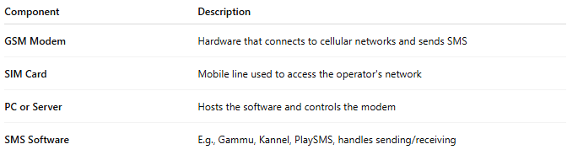

Component | Description
GSM Modem | Hardware that connects to cellular networks and sends SMS
SIM Card | Mobile line used to access the operator's network
PC or Server | Hosts the software and controls the modem
SMS Software | E.g., Gammu, Kannel, PlaySMS, handles sending/receiving

📊 Features:
# Source: AI Source: Provided by: [Data Path: Persons Table -> ID Column: 1, Name_En Column: Motasem Essam] -> From: [Chatgpt (GPT‑5 Mini)] on [1/21/2026]
- Sends messages via mobile network, not internet
- Works offline, ideal for remote or restricted environments
- Full control of SMS flow and storage
- Can receive replies (2-way SMS)

✅ Pros:
# Source: AI Source: Provided by: [Data Path: Persons Table -> ID Column: 1, Name_En Column: Motasem Essam] -> From: [Chatgpt (GPT‑5 Mini)] on [1/21/2026]
- No internet required
- Cost-effective for local SMS
- Easy to set up in small environments
- Full data ownership
- Good for low-volume or internal messaging

❌ Cons:
# Source: AI Source: Provided by: [Data Path: Persons Table -> ID Column: 1, Name_En Column: Motasem Essam] -> From: [Chatgpt (GPT‑5 Mini)] on [1/21/2026]
- Limited throughput (typically 6–10 SMS per minute per modem)
- Carrier limits (some carriers block bulk sending)
- Hardware can wear out or be unstable
- Needs manual monitoring and maintenance

🏢 On-Premise SMS Server vs 📡 GSM Modem-Based SMS
# Source: AI Source: Provided by: [Data Path: Persons Table -> ID Column: 1, Name_En Column: Motasem Essam] -> From: [Chatgpt (GPT‑5 Mini)] on [1/21/2026]
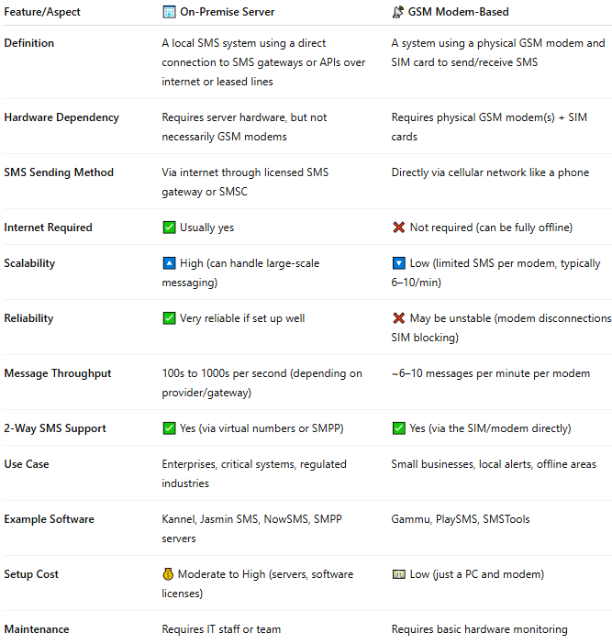

Feature/Aspect | 🏢 On-Premise Server | 📡 GSM Modem-Based
Definition | A local SMS system using a direct connection to SMS gateways or APIs over internet or leased lines | A system using a physical GSM modem and SIM card to send/receive SMS
Hardware Dependency | Requires server hardware, but not necessarily GSM modems | Requires physical GSM modem(s) + SIM cards
SMS Sending Method | Via internet through licensed SMS gateway or SMSC | Directly via cellular network like a phone
Internet Required | ✅ Usually yes | ❌ Not required (can be fully offline)
Scalability | 🔼 High (can handle large-scale messaging) | 🔽 Low (limited SMS per modem, typically 6–10/min)
Reliability | ✅ Very reliable if set up well | ❌ May be unstable (modem disconnections, SIM blocking)
Message Throughput | 100s to 1000s per second (depending on provider/gateway) | ~6–10 messages per minute per modem
2-Way SMS Support | ✅ Yes (via virtual numbers or SMPP) | ✅ Yes (via the SIM/modem directly)
Use Case | Enterprises, critical systems, regulated industries | Small businesses, local alerts, offline areas
Example Software | Kannel, Jasmin SMS, NowSMS, SMPP servers | Gammu, PlaySMS, SMSTools
Setup Cost | 💰 Moderate to High (servers, software licenses) | 💵 Low (just a PC and modem)
Maintenance | Requires IT staff or team | Requires basic hardware monitoring

🧩 Summary:
- ✅ Choose On-Premise Server if you want high-volume, enterprise-grade, or secure SMS systems that integrate with APIs/gateways but stay hosted locally.
- ✅ Choose GSM Modem-Based if you want a low-cost, offline, or localized solution for sending a small number of SMSs using SIM cards.

🆚 Compared to Other Delivery Types:
# Source: AI Source: Provided by: [Data Path: Persons Table -> ID Column: 1, Name_En Column: Motasem Essam] -> From: [Chatgpt (GPT‑5 Mini)] on [1/21/2026]
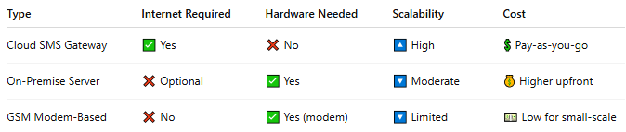

Type | Internet Required | Hardware Needed | Scalability | Cost
Cloud SMS Gateway | ✅ Yes | ❌ No | 🔼 High | 💲 Pay-as-you-go
On-Premise Server | ❌ Optional | ✅ Yes | 🔽 Moderate | 💰 Higher upfront
GSM Modem-Based | ❌ No | ✅ Yes (modem) | 🔽 Limited | 💵 Low for small-scale

📦 Common Use Cases:
# Source: AI Source: Provided by: [Data Path: Persons Table -> ID Column: 1, Name_En Column: Motasem Essam] -> From: [Chatgpt (GPT‑5 Mini)] on [1/21/2026]
- Internal alert systems
- Low-cost bulk SMS
- Remote regions with no stable internet
- Emergency broadcast systems
- Prototype/test environments

